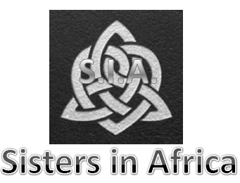 Membership Application
Email: sia@independence-commission-africa.org
Website: http://icazar.weebly.com/sia-home.html
Cel: (+27) 613226912
Twitter: @IcaAfrica
Welcome to SIA!

The crucial task of SIA is the coaching young girls between the tender ages of 14-18 and the educating and empowerment of young women between the ages of 18-35, through providing them with vital information regarding them personally, and which will also intensify their independence.
Generally in South Africa, and Africa as a whole, many women and children are still facing inequality, as well as injustice, during their developmental stages because of social pressures, peer pressure and also fears from insufficiency, low self esteem, and other socio-economic and environmental issues.
Young women are isolated and ill-informed when it comes to economic independence, which leads to many women with great potential losing grasp of their visions and dreams, leaving some too frightened in reaching their full potential.
Sisters of Africa realised this gap in society, then decided to take a stand against negative factors through informing, educating, empowering and restoring the place of young women in modern day society, and also assisting in educating them on financial matters.
Our aim is to make certain that our young women are fully independent in all sectors of life, which includes: * informing *educating *empowering *restoring *financial education
You are heartily invited to join us!

Warm regards,
GuGu Khathi
Project Manager

Please note: Sisters in Africa (SIA) is part of the Social branch of Independence Commission Africa NPO Reg. 127-964.

Applicant Information

Title: |  | Surname:
Names: |  | Known as:
Date of birth: |  | Male/Female:
Area you live in: |  | Area you would like to live in:
Current address:
City: | Country: |  |  | ZIP Code:
Contact number: |  | Email address:

Your comments:

Signatures
I agree to work within the legal system of the South African government.
Signature of applicant: Date:
Signature of SIA Representative: |  |  | Date:
MEMBERSHIP FEES
Annual membership fees of R20 is payable to SIA for which a receipt and membership number will be issued within 7 days, payable into account:
Please use your name and surname as reference upon payment. Thank you for your support!

